**Title: Bug Report – Missing Cart Link in Notification**

* **Date Reported: 6/3/2025**
* **Bug ID: BUG-CART-001**
* **Module: Add product to cart**
* **Severity: Major**
* **Priority: High**
* **Status: Open**
* **Reported By: NourEl-Dien Nwara**

**Description:**

**When a user adds a product to the cart, the notification message appears but does not include a link to redirect the user to the cart page. This affects the user experience as they must manually navigate to the cart instead of using a direct link.**

**Steps to Reproduce:**

1. **Navigate to a product page.**
2. **Click on the "Add to Cart" button.**
3. **Observe the notification message that appears.**
4. **Look for a link to the cart within the notification.**

**Expected Results:**

**The notification message should contain a clickable link redirecting the user to the cart page for easy access.**

**Actual Results:**

**The notification appears but does not include a link to navigate to the cart. Users must manually go to the cart page.**

**Environment:**

* **Website:** [**demoblaze**](https://www.demoblaze.com/)
* **Browser: Chrome / Edge / Firefox**
* **Device: PC / Mobile**

**Attachments:**

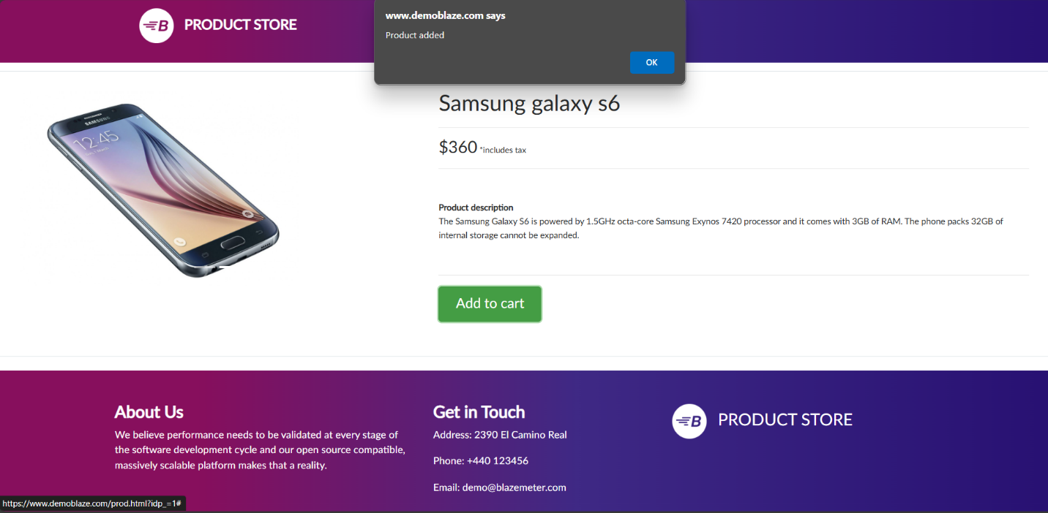

**Title: Bug Report – Adding Products to Cart Without Login**

* **Date Reported: 6/3/2025**
* **Bug ID: BUG-CART-002**
* **Module: Add product to cart**
* **Severity: Major**
* **Priority: High**
* **Status: Open**
* **Reported By: NourEl-Dien Nwara**

**Description:**

**Users can add products to the cart without logging into their account, which contradicts the acceptance criteria. The system should restrict adding products to the cart unless the user is logged in.**

**Steps to Reproduce:**

1. **Open the website in a new browser session.**
2. **Do not log in to any user account.**
3. **Navigate to a product page.**
4. **Click on the "Add to Cart" button.**
5. **Observe that the product gets added to the cart.**

**Expected Results:**

**The system should prompt the user to log in or sign up before allowing them to add products to the cart.**

**Actual Results:**

**The system allows users to add products to the cart without logging in.**

**Environment:**

* **Website:** [**demoblaze**](https://www.demoblaze.com/)
* **Browser: Chrome / Edge / Firefox**
* **Device: PC / Mobile**

**Attachments:**

**Title: Bug Report – Product Quantity Visibility Issue**

* **Date Reported: 6/3/2025**
* **Bug ID: BUG-CART-003**
* **Module: Add product to cart**
* **Severity: Medium**
* **Priority: Moderate**
* **Status: Open**
* **Reported By: NourEl-Dien Nwara**

**Description:**

**The number of available products in stock is not clearly visible to the user on the product page. This can lead to confusion regarding how many items are available for purchase.**

**Steps to Reproduce:**

1. **Open the website.**
2. **Navigate to any product page.**
3. **Look for the stock quantity or number of available products.**
4. **Observe whether the information is clearly displayed.**

**Expected Results:**

**The available stock quantity should be clearly visible next to the product price or "Add to Cart" button.**

**Actual Results:**

**The stock quantity is either missing, too small, or not prominent enough, making it difficult for users to determine how many items they can purchase.**

**Environment:**

* **Website:** [**demoblaze**](https://www.demoblaze.com/)
* **Browser: Chrome / Edge / Firefox**
* **Device: PC / Mobile**

**Attachments:**

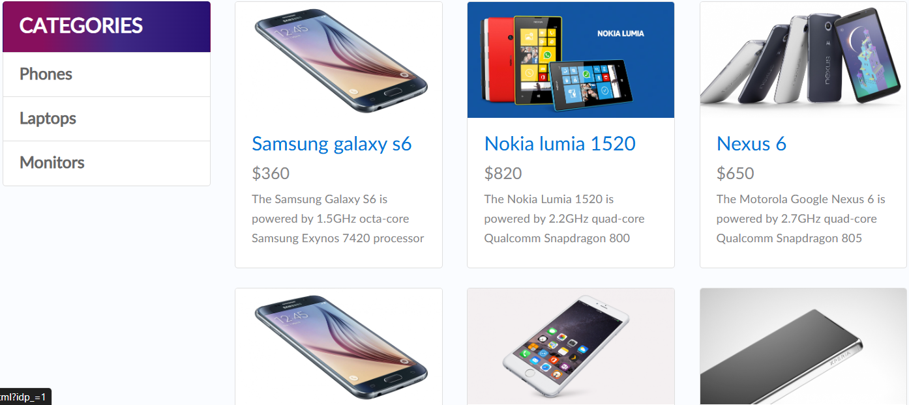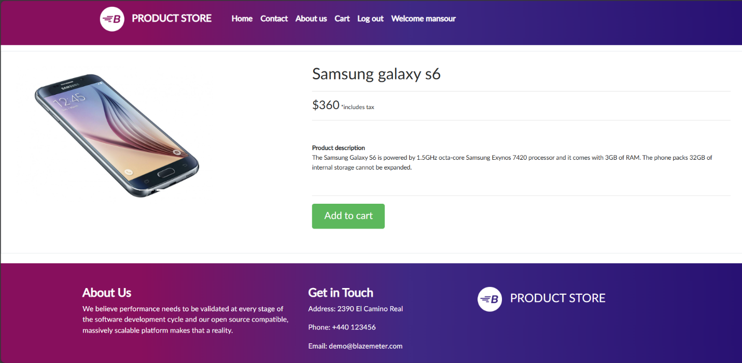

**Title: Bug Report – Contact Us Form Issue**

* **Date Reported: 6/3/2025**
* **Module: Contact Us**
* **Bug ID: BUG-CONTACT-001**
* **Severity: Critical**
* **Priority: High**
* **Status: Open**
* **Reported By: NourEl-Dien Nwara**

**Description:**

**The "Contact Us" form accepts submissions even when all fields are empty or invalid. There are no validation checks in place, allowing users to submit incomplete or incorrect information.**

**Steps to Reproduce:**

1. **Navigate to the Contact Us page.**
2. **Leave all fields empty and click Submit.**
3. **Enter invalid email formats (e.g., test@ or test@domain).**
4. **Enter a message exceeding 500 characters.**
5. **Click Submit after each test case.**

**Expected Results:**

**The system should display validation messages for:**

* **Mandatory fields (Name, Email, Message).**
* **Invalid email format (should follow name@domain.xyz).**
* **Exceeding character limit in the message (500 characters max).**

**Actual Results:**

**The form accepts all inputs, even if:**

* **Fields are left blank (No validation messages).**
* **Email format is incorrect.**
* **Message exceeds the allowed limit.**

**Environment:**

* **Website:** [**demoblaze**](https://www.demoblaze.com/)
* **Browser: Chrome / Edge / Firefox**
* **Device: PC / Mobile**

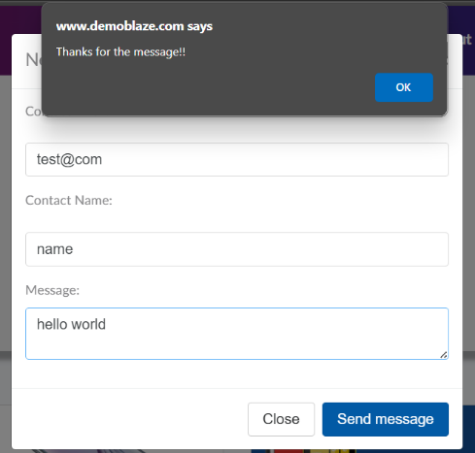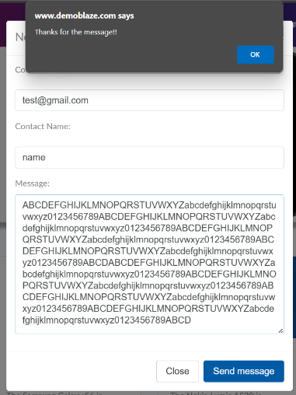**Attachments:**